September Newsletter  2022-23 SEASON FOR U8-U12 age groups at Wycombe Hockey Club  TRAINING: Minis sessions will take place on Saturday mornings at Wycombe High School from 8.30-10am. All age groups U8-U12 are invited to these sessions and parents are encouraged to watch throughout inside the fence and listen to the squad de-brief at the end of the session. Our minis mornings will begin on Saturday 10th September. Any parent volunteers with hockey experience do please come and have a chat…we would LOVE for you to get involved.  U12 boys and girls (Years 6 & 7) will have additional training on Thursday nights from 6-7.30pm - these will start on September 8th and take place at RGS.  Please can we ask that parents always check their children have shin pads and a mouth guard. Children will not be allowed to play at all without them. We would also ask that you make the session leader aware of any medical issues, injuries or other important information at the start of EVERY session. If your child uses an inhaler – please make sure they always have it at training and fixtures.  MATCHES: The schedule is still being finalized by the leagues but the first matches are likely to take place on Sunday 2nd October.  We will update the calendar on the club website as soon as we have confirmation of fixtures.  If your child is selected for a match please respond promptly to selection emails as it really helps the team managers to know who is available to play. | Contact us:  We would love you to join the mini’s whatsapp group for regular info and updates – please use this joining link:  https://chat.whatsapp.com/Ie3EVm2AjHI7JEf3S5bxrA  WHC MINIS CONTACTS:  emmawalden@hotmail.com – U12  nancy_c_b@hotmail.com - U10  ollybritnell@hotmail.com – U10  eashlin@hotmail.co.uk – U8  Each age group will have a WhatsApp Group to ensure communication with parents and volunteers. Please look out for this once the season begins.  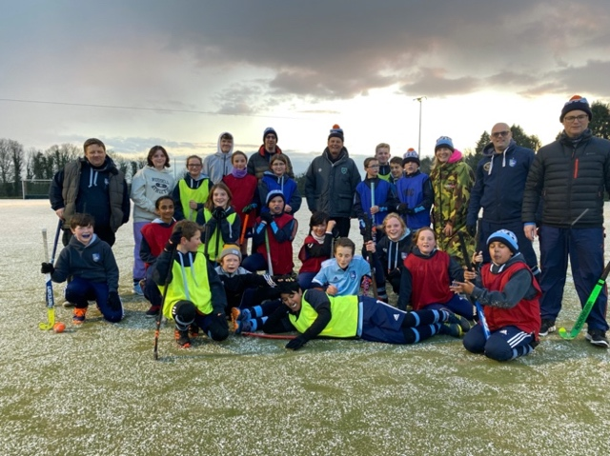The Minis are a stoic lot and play in all weathers – even a light sprinkling of snow this year! Please make sure your children are well equipped with gloves, hats, and thermal top and bottom layers throughout the winter months – warm hockey players are happy hockey players!

